21st July 2011.

DAYANAND SHILP VIDYALAYA
(Run by Bandhua Mukti Morcha)
GARHI, EAST OF KAILASH
NEW DELHI

PROGRESS REPORT

(Computer Trade/Cutting & Tailoring / Beauty Culture)

Prepared by: ANJU VERMA .
(Computer Teacher) .

Computer Trade:

- Internet Facility has been introduced since January 2011, in the center. This helped in a greater way to the students as they become aware of the use of internet in their day to day life and understood how internet is important in personal and professional level.
- Presently 4 batches are running since 10 AM to 5 PM everyday. The total number students in all the four batches are 32.

- Various trade related competitions has been organized to prepare students for the competitive environment – like typing competition etc.
- Student visits to nearby small offices and departmental stores, where computer applications are being used, has been organized to make them aware to the practical environment, which will help them in their carrier.
- There are few girls from the last batch who have got placements in various companies and started supporting themselves and their families.
- Some of the girls who left their studies midway due to lack of money have also started working part time after doing the computer course from our center and now they are supporting their education by their own.
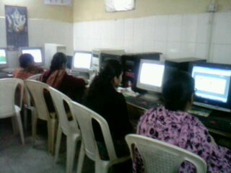

Cutting & Tailoring:

- Presently there are 2 batches running from 1 pm to 5 pm daily and the total students are 20.

- Students were taken to various boutiques and guided on how they can work in real environment and can even start their own boutique as well.

- Some of the students have started their own stitching arrangements at their homes and some of the girls are employed with boutiques.

- On behalf of Swami ji, some of the students have been helped in starting their own venture by donating them stitching machines.

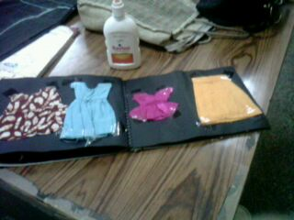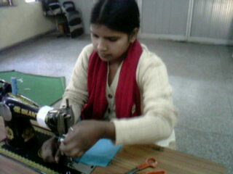

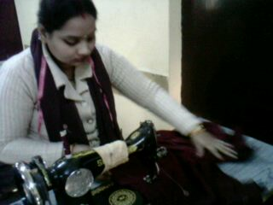

Beauty Culture:

- Presently there are 2 batches running from 1 pm to 5 pm daily and the total students are 20.

- Students were taken to various beauty parlors and guided on how they can work in real environment and can even start their own beauty parlor as well.

- Most of the students are working with local beauty parlors and even started their own venture at home.

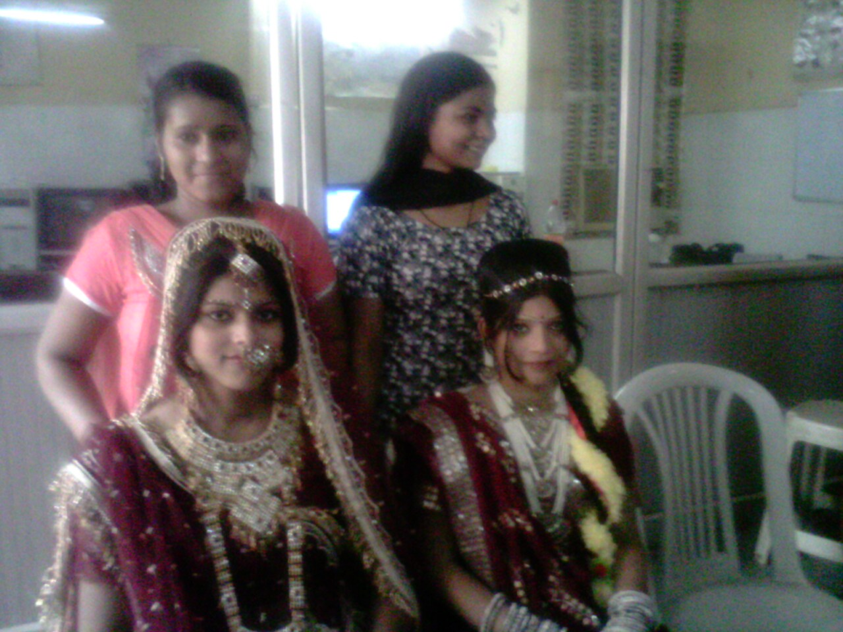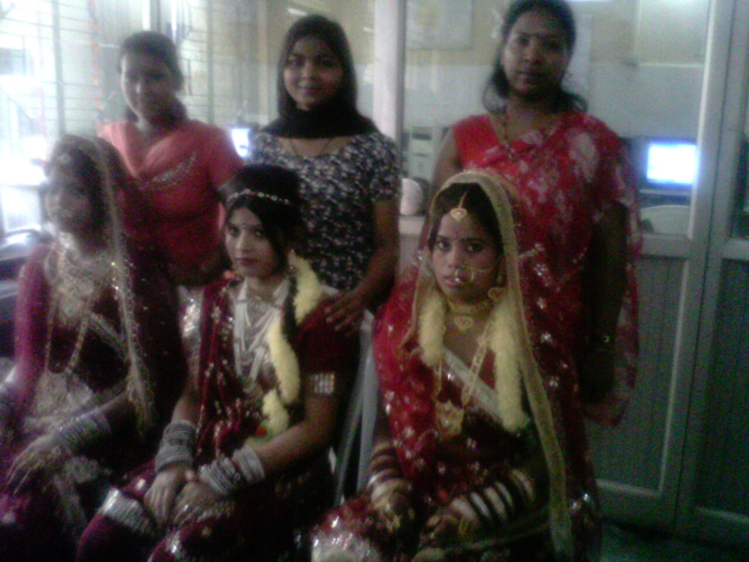

Combined activities of all the trades:

- We had also organized combined debate on the issue of corruption in the centre and students were made aware on the fight against corruption.
- Lectures on various social issues like dowry and girl feticide have been given to the students from time to time.


- Last week a seminar on art and craft had been organized in the centre. Student of all the trades were present in the seminar and benefited.

With regards from:
DAYANAND SHILP VIDYALAYA, Garhi, East of Kailash.

STAFF DETAILS

Computer Trade: Anju Verma

Cutting & Tailoring: Prem Lata

Beauty Culture: Sonia Basbal
Peon: Gagan

